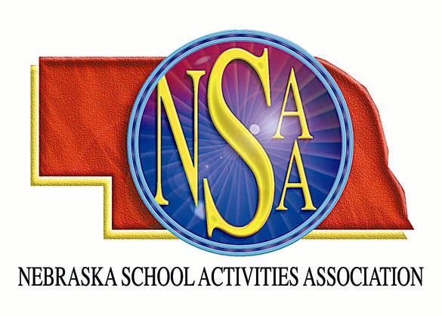
ENOA/NSAA FOOTBALL
OFFICIALS’ CLINIC

The Eastern Nebraska Officials Association and Nebraska School Activities Association will sponsor a football officiating clinic at Lincoln East High School and Seacrest Field in Lincoln, Nebraska. There will be two Class A schools conducting intra-squad scrimmages in the morning. Officials should come prepared to officiate. Knickers and socks are not required. Attendees will be divided into two groups for the morning sessions. Each group will have field time and classroom time.

Football Officials Clinic

Seacrest Field,

72 nd and A Streets, Lincoln
Saturday, August 12, 2006
Check In: 8:00 am – 8:30 am
Classroom /Field Sessions: 8:30 am – Noon
Lunch: noon – 1:00 pm
Position Session: 1:00 pm – 1:45 pm
NSAA Rules Meeting 2:00 – 3:00 pm

$ 20.00 Non-Refundable Registration Fee

Complete the registration form with all the necessary information and enclose payment of $20.00.
The fee is non-refundable.

Limited enrollment, please pre-register.

Return by August 1, 2006

Name______________________________

Address ___________________________

___________________________________-
__________________________________
Zip

Telephone # ________________________

E-mail _____________________________

Yrs. Experience_____________________

Position____________________________

MAIL TO: NSAA
P.O. Box 5447
Lincoln, NE 68505-0447

